**FELSTED PRIMARY SCHOOL**

ACCESSIBILITY PLAN



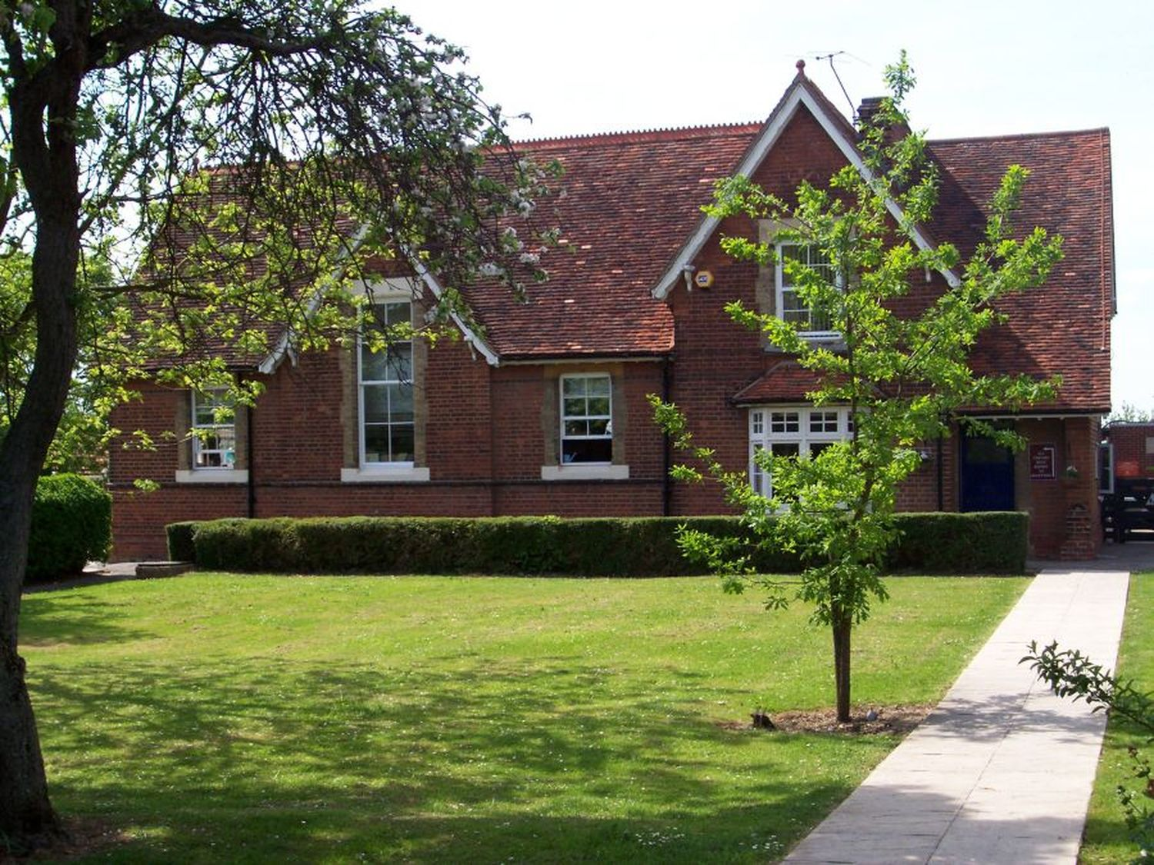



The Equality Act 2010 introduced a single Public Sector Equality Duty, which came into effect in April 2011. It has three main aims. In carrying out their functions public bodies are required to have due regard to the needs of children and adults to:

● Eliminate discrimination and other conduct that is prohibited by the Act

● Advance equality of opportunity between people who share a protected characteristic and people who do not

● Foster good relations across all characteristics

The Equality Act defines disability as when a person has ‘ *physical or mental impairment which has a substantial and long term adverse effect on the person’s ability to carry out normal day to day activities’*

**At Felsted Primary School our aims are :**

● not to treat disabled pupils less favourably for a reason related to their disability;

● to make reasonable adjustments for disabled pupils, so that they are not at / a substantial disadvantage;

● to plan to increase access to education for disabled pupils.

It is a requirement that the school’s accessibility plan is resourced, implemented and reviewed and revised as necessary. This plan sets out the proposals of the Governing Body of the school to increase access to education for disabled pupils in the three areas required

● increasing the extent to which disabled pupils can participate in the school curriculum;

● improving the environment of the school to increase the extent to which disabled pupils can take advantage of education and associated services;

● improving the delivery to disabled pupils of information which is provided in writing for pupils who are not disabled.

**Duties of the Governing Body**

● To publish information annually to provide information on how the school has due regard to the need to eliminate discrimination and harassment, advance equality and foster good relations and the outcome achieved.

● Prepare and publish equality objectives at least every four years

**Vision and Values**

Felsted Primary School makes all children and adults feel welcome irrespective of race, colour, creed or impairment. We have high ambitions for our disabled pupils and expect them to participate and achieve in every aspect of school life.

Our school:

● sets differentiated learning challenges so that disabled pupils can participate in the curriculum;

● responds to pupils’ diverse needs by adapting the physical environment to increase the extent to which disabled pupils can be included;

● overcomes potential barriers to learning and assessment for individuals and groups of pupils by differentiation, providing suitable support and seeking advice from specialist teachers where appropriate.

● seeks to eliminate discrimination and promote equal opportunities for disabled members of staff, parents/carers and the users of the school ensures that disabled pupils participate fully in school trips, visits and out of school activities /

The school has a clear SEN policy in place and the SENCo identifies and tracks the needs, support and progress of vulnerable pupils. A SEND register is updated regularly showing the number of pupils requiring extra support to access the curriculum and identifying the support needed to help them achieve this. This may be through teaching assistant support, following specific intervention programmes, incorporating specific resources and advice from outside agencies into delivery of the curriculum.

The school works closely with playgroups to identify children who will need extra or specialist support on entry. Children with a variety of disabilities are welcomed and integrate well. No child has ever been refused admission to the school because of disability and no disabled child has been excluded

Attendance of pupils with disabilities and SEN is in line with the attendance of all pupils.

**School information**

The school supports the inclusion of disabled pupils in every aspect of school life e.g. sports teams, music groups, school trips, school journeys and after school clubs. The needs of staff with disabilities is addressed as needed.

A Gym Trail for children with motor co-ordination difficulties is provided as part of the class learning.

Children with social communication difficulties find lunch and breaktime challenging. The school understands this and additional support has been put into place to support those children at these times

Children with Speech and Language difficulties are supported through special programmes designed in liaison with our link Speech and Language Therapist.

Advice from Physical and Neurological, Hearing Impairment and Visual Impairment Specialist teachers is regularly sought and implemented in the child’s One Plan as appropriate.

Office staff and class teachers have all received specialist training to support children with specific medical needs. Staff are made aware of children with specialist needs thrpugh training and care plans where appropriate.

**Evaluation and links with outside agencies**

Targets are set and reviewed at termly One Plan meetings in consultation with the child, parents, class teacher and SENCo.

**Local Authority**: Training from specialist teachers and equipment is provided when needed.

**Health Authority**: Advice and assessments are undertaken as needed

**The main priorities in the school’s plan**

**Increasing the extent to which disabled pupils can participate in the school curriculum**

The level of differentiation within the school should enable all children to access the curriculum. When a child has a specific disability there is a close working relationship with the specialist teaching team ensuring all aids and adaptions are made to reduce any barriers to progress. The SENCo monitors progress of all children with a Disability or Special Educational Needs using a tracking grid for Vulnerable children. Intervention / programmes for children who need specific support are planned in September and monitored termly through One Planning.

Additional support for children with social and communication and behaviour difficulties has been put ion place at lunch/paly times. Networks and collaboration Dunmow Excellence in Education Partnership has successfully bid for funding under the Inclusive Schools Project and training has been undertaken to;

● Train and support TAs as learning mentors

● Share expertise within the group of schools

● Support vulnerable children and parents to develop positive attitudes towards learning.

**Improving the physical environment**

The school already has previously carried out an audit of the school environment considering aspects of the physical environment for pupils with different impairments. A variety of adaptations have been made including:

● ramps for wheelchair access

● toilets are accessible for wheelchair users

● training is undertaken to ensure disabilities are understood and catered for

● specific training by medical professionals is undertaken for specific children with medical and physical needs for teachers, LSAs and Office staff

● a record is kept centrally of children who may need medical intervention

● the school will consult the recommendations made by the Statutory Assessment Service for children with specific disabilities and will put these in place when a child with a disability enters school

Further improvements will be linked to the School Improvement Plan (SIP). Funding for any improvements required will come from devolved formula capital.

**Improving the delivery of information to disabled pupils and personnel**

Print will be enlarged to meet the needs of any visually impaired pupils . Pictures and symbols are widely used to help children with social communication difficulties.

More specialised formats will be accessed as the need arises.

Gym Trail is in place for children with Motor Coordination Difficulty and a writing programme (Write from the Start and Finger Gym) to develop fine motor control skills.

**Management, coordination and implementation**

Members of staff are already committed to removing barriers and increasing access to good practice is shared and progress of pupils is monitored during INSET and staff training meetings.

The Governing body will discuss the School Inclusion Plan and will set priorities relating to their responsibilities . These will include:

● how the Governing body will oversee the plan

● monitoring of implementation

● how and when the plan will be reviewed

● reporting to parents

Implementation of the plan will be part of the School Improvement Plan.

**Reporting requirements**

The Governing body is required to report to parents on the School Accessibility Plan:

● arrangements for the admission of disabled pupils

● steps taken to prevent disabled pupils from being treated less favourably

● facilities provided to assist access

● report on school’s SEN policy.

The plan will be available on the school website.

Reviewed and agreed

Date…………………Signature of Chair of Governors……………………………………